CA2 BYOD – ADVANCE LINUX

1. User and Group Management
- Create a new user account named "devuser" with the following specifications:
  - Home directory: /home/devuser
  - Shell: /bin/bash
  - Comment: "Developer User"
- Create a new group named "developers".
- Add "devuser" to the "developers" group.
- Verify the user and group setup.
Expected Output: Should show "devuser" with "developers" in the group list.

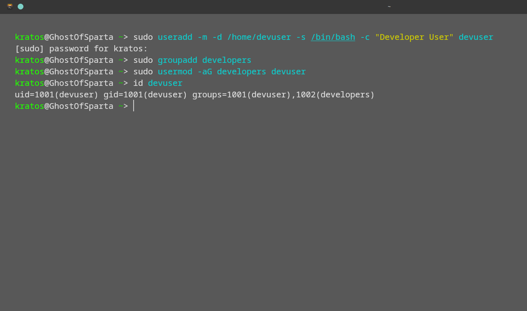

2. File Permissions
- Switch to "devuser".
- Create a directory named "projects" in the home directory.
- Set permissions on "projects" so that:
  - The owner has read, write, and execute permissions (rwx).
  - The group has read and write permissions (rw-).
  - Others have no permissions (---).
- Verify the permissions.
Expected Output: Should show drwxrw---- followed by ownership details.

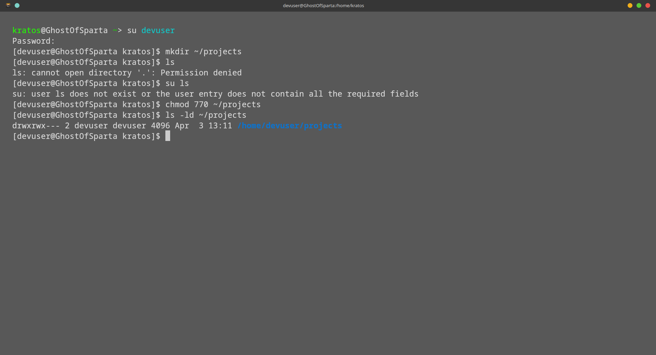

3. Process Management
- While logged in as "devuser", start a background process using the sleep command for 1000 seconds.
- List processes to find the PID of the sleep process.
Expected Output: Look for "sleep 1000" and note its PID.
- Terminate the sleep process using its PID.
- Confirm the process is terminated.
Expected Output: "sleep 1000" should no longer appear in the process list.

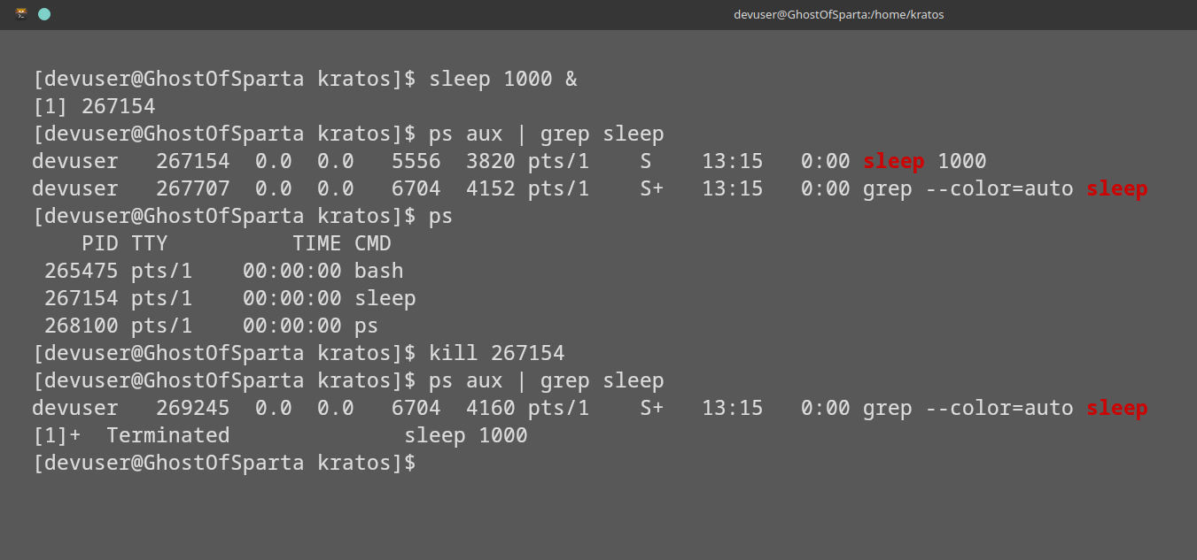

4. Task Scheduling
- As "devuser", create a script named "hello.sh" in the "projects" directory with the following content:
bash
#!/bin/bash
echo "Hello, World!"
- Make the script executable.
- Schedule a cron job to run the script every minute.
- Verify the script runs (wait 1 minute).
Hint: You may check system logs or look for output manually.

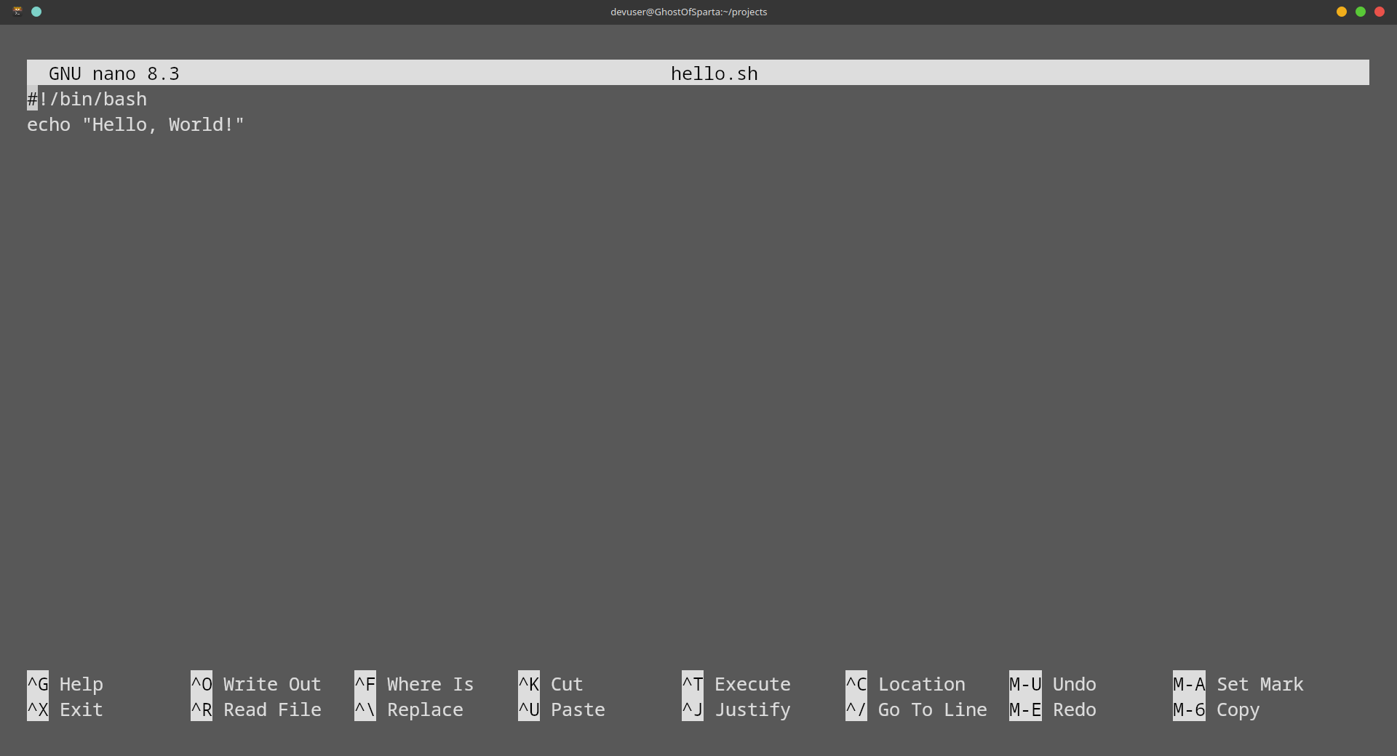

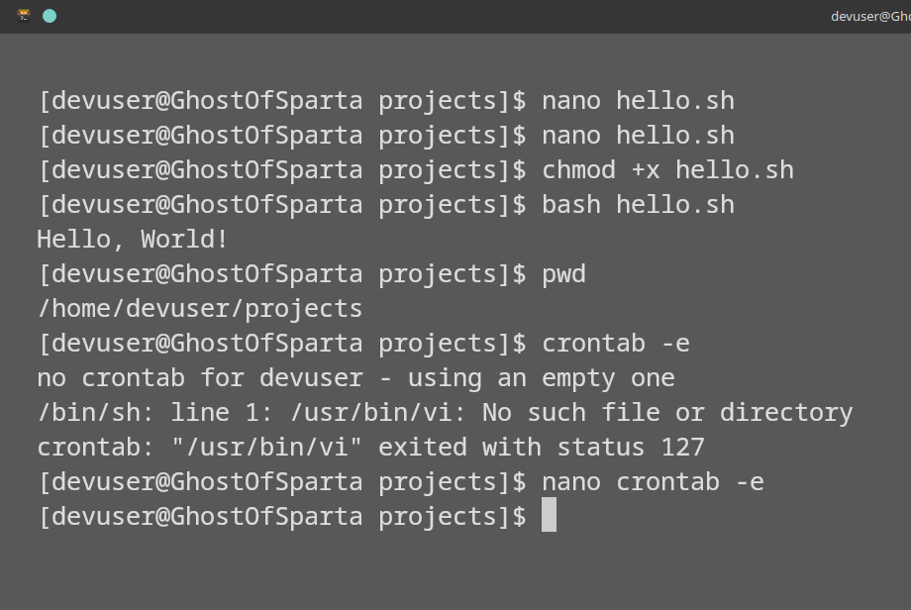

5. Resource Monitoring
- Exit back to your original user.
- Check memory usage.
Action: Note the "used" and "available" memory values.
- Monitor processes.
Action: Observe for a few seconds, then exit the monitoring tool.

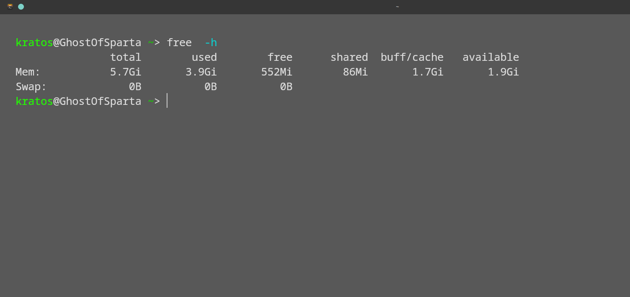
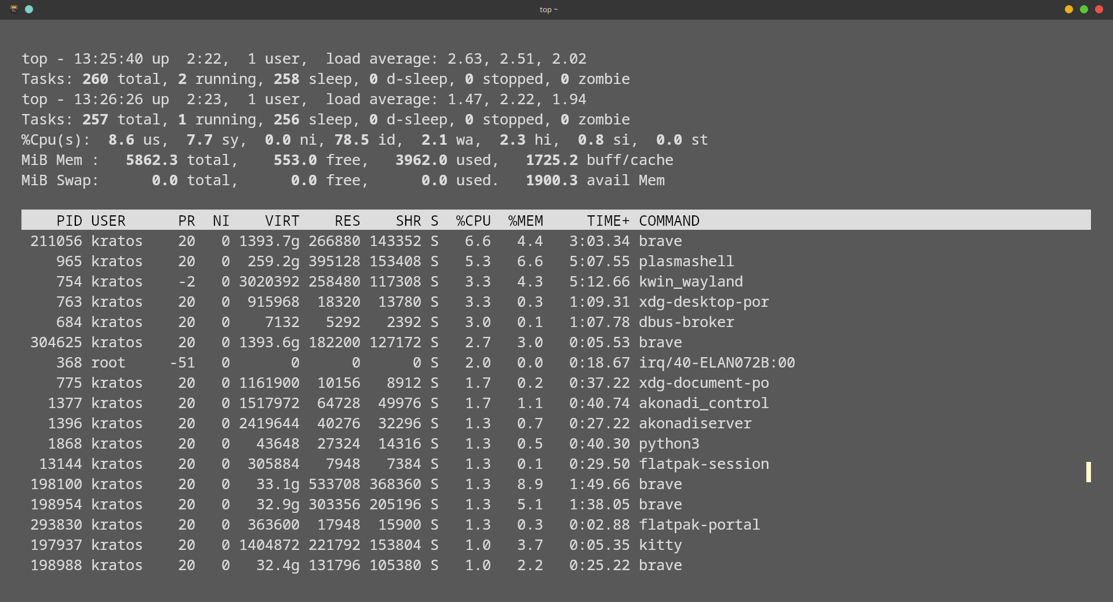

6. Package Management
- Install the "htop" package.
- Run "htop" to monitor resources briefly.
Action: Explore the interface, then exit.
- Remove the "htop" package.

